Exercise 2: ServiceNow Studio

**NOTE**: Before you begin with this exercise, you **must** complete the exercise found on the last slides of the powerpoint #2 presented during the lecture.

General Instructions:

1. Open the **Innovate** application in the Studio.
   1. Search the **Studio** application module in the **All** navigation menu (*All > System Applications > Studio*).
   2. Click the **Innovate** application in the **Select Application** window.
2. Click the **Create Application File** menu and search for the required application files (e.g., Table Column, List Layout) in the search bar. Click the create button.

Using your personal instance, do the following in **ServiceNow Studio**:

1. Create table column fields.
   1. **Review status** (Choice, choices in this order={Not started, In progress, Reviewed})

→ Set *Not started* as the default value

* 1. **Assigned to** (Reference to User[sys_user])

1. Create the list default layout if it is not already listed on the Application Explorer panel. Set the list default layout of the table in this order:
   1. Number ← leftmost column
   2. Short description
   3. Description
   4. Idea type
   5. Review status
   6. Assigned to ← rightmost column
2. Create a new list layout view named, **Report view**.
3. Set the list layout of the Report view in this order:
   1. Number ← leftmost column
   2. Assigned to
   3. Short description
   4. Idea type
   5. Review status
   6. Created
   7. Updated ← rightmost column
4. Create the form default layout if it is not already listed on the Application Explorer panel. Organize the form default layout of the table in this order:

| Number |
| --- |
| Idea type |
| Review status |
| Short description |
| Description |
| Assigned to |

1. Create a new form layout view named, **Proposal view**.
2. Organize the form layout of the Proposal view in this order:

| Number | Created |
| --- | --- |
| Idea type | Updated |
| Review status | Assigned to |
| Short description | |
| Description | |

1. Create additional application modules for the following in this order:
   1. My assigned items - displays table records that have been assigned to the **currently logged in user**
   2. Open - displays table records that have not yet undergone review
   3. Reviewed - displays table records that have already been reviewed

Final Output:

1. Use the *Student Output Template* excel file. Paste screenshots of your activity showing that you had successfully accomplished each task. Put captions above each screenshot.

File name: **<Block_ExerciseNo/Title_Lastname.xlsx>**

Example:

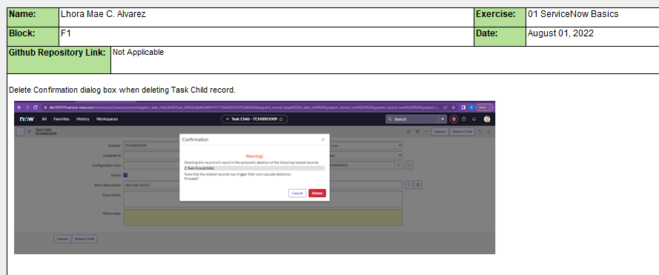

Sample Output:

1. *Created table fields:* ***Review status*** *and* ***Assigned to****.*

